User Guide - A CV Based Measurement System for RAVEN

## 1. Overview

This system is able to measure a point position in a space (about 30cm x 30cm x 30cm), with an accuracy of about 1-2 mm after calibration.

A main advantage of this system is the low cost (around $100, mainly decided by the 4 cameras). A main disadvantage is the low recording rate(10hz) and offline processing(for 1000s recording, the processing may take 2-3 hours)

## Hardware

**Webcams X 4:** we are using 4 Logi C270 webcam(about $18 each) and they work well. However, other webcams should be okay as long as they can be driven and provide a ROS topic.

**Camera holder:** 3-D printed parts, they are used to fix the cameras. There is no accuracy requirement of these holders as long as the can tightly fix the cameras.

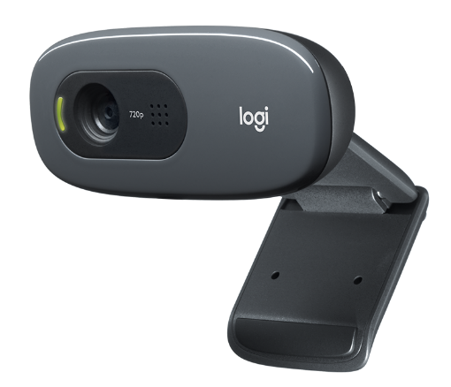 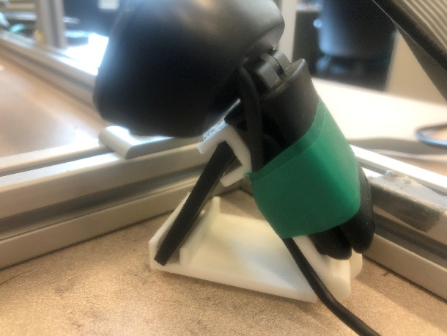

**Ball holder:** 3-D printed parts, which is used to fix 3 colored balls on the object you want to measure (the positional relation of the three balls’ centers and the point you want to measure should be known). This part should be as accurate as it could be, because the final accuracy of solving the position relies on this. The following picture shows the ball holder for RAVEN’s end effector. If you use other holder, some constant in the end effector solver need to be changed (will be introduced later). The 3-D model of the part is not provided in the open-source repo because it contains copyright of the end effector. If you are working on the same RAVEN and need the model, please contact us.

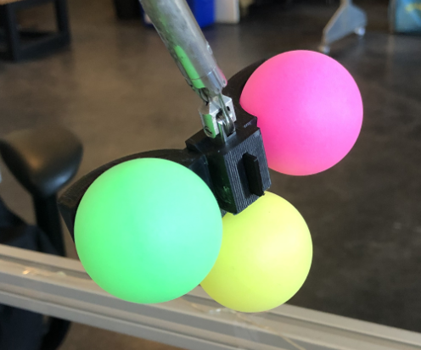 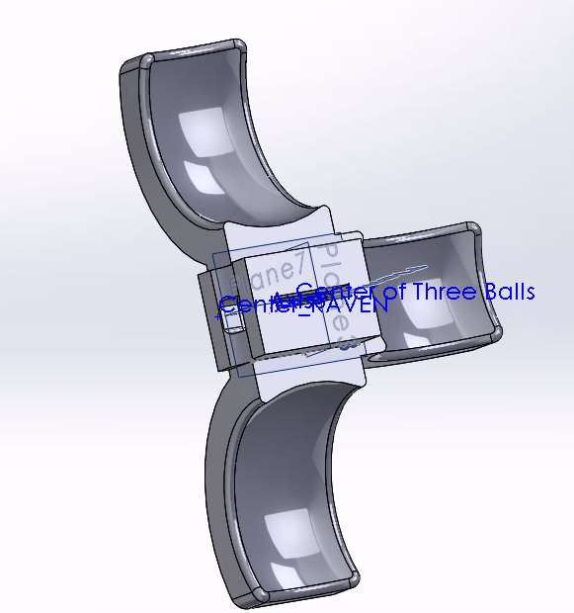

**Colored Balls:** These colored balls are for circle detection. Same as ball holder, they need to be fixed around the measurement object. Currently, red(or pink), yellow and green colors are recommended. The following link are the balls we bought.(d = 38mm)

<https://www.amazon.com/gp/product/B01N5TKGNX/ref=ppx_yo_dt_b_search_asin_title?ie=UTF8&psc=1>

**Chessboard**: 3-D printed parts, which is for the first step of the cameras’ localization. Usually, this part does not need to be very accurate. But it is not difficult to make it accurate so accuracy is recommended. The origin point and the orientation of the chessboard should be known.

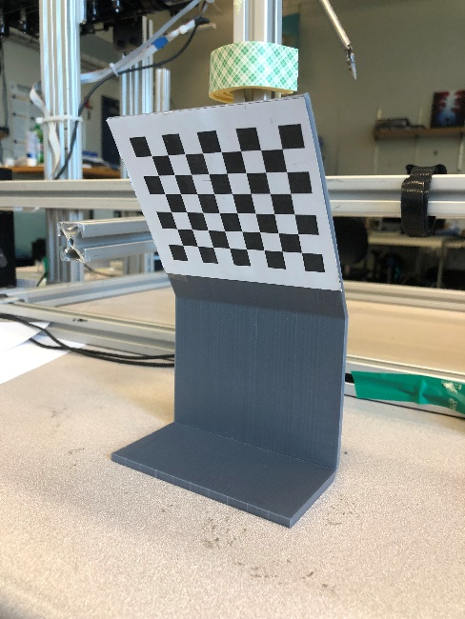 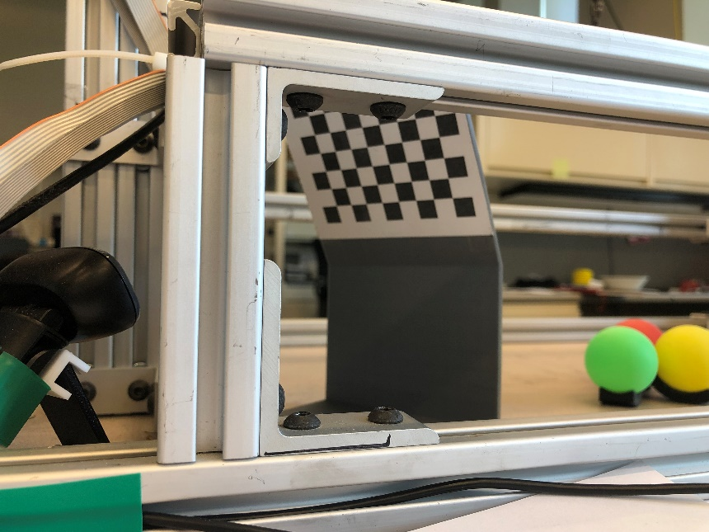

**Marker:** This is the only accurate part for the cameras’ localization. It is used to provide know points around and inside the workspace you want to measure. The final accuracy relies on the accuracy of this part. In the following pictures, the centers of the crosses are the marker points. When placing on a table, the pillar is vertical and the height of the centers are known. You can use any kind of marker as long as it is accurate.

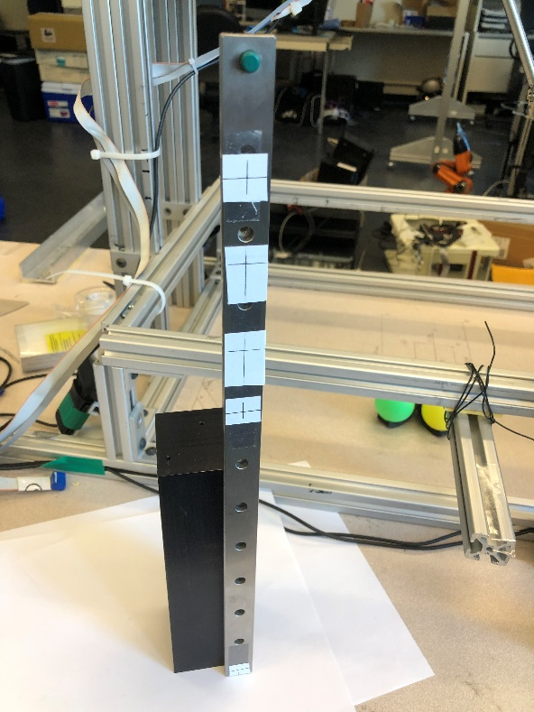 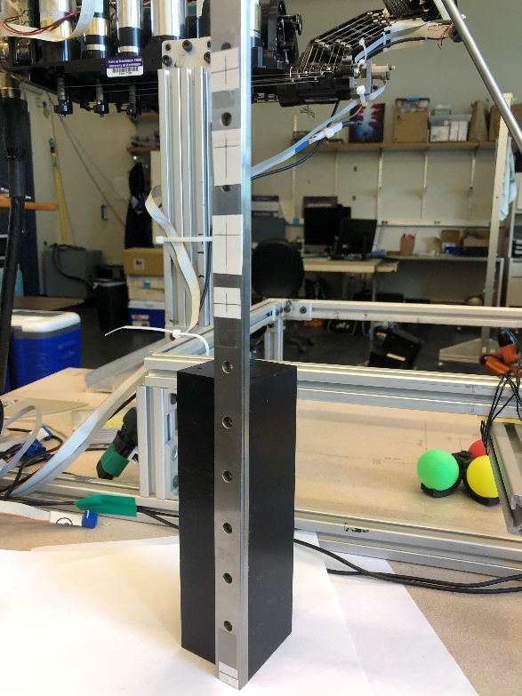

**Camera holder(optional) x 4:** 3-D printed parts, it is just used to fix cameras.You are free to choose any fixing method. For us, we are using a very simple 3-D printed camera holder to do so. The model can be found in the ‘Solidworks Model/camera’ folder. You can print different size of the slice(the black part) to adjust the pitch of the camera. (For the C270 camera, it has a hinge to adjust pitch. However, it is not recommended because if you use that, a single touch during recording may change the pitch, which is catastrophic because the program requires the cameras to be strictly fixed. Thus, always keep that hinge to lower limit is recommended, just as the following picture shows )

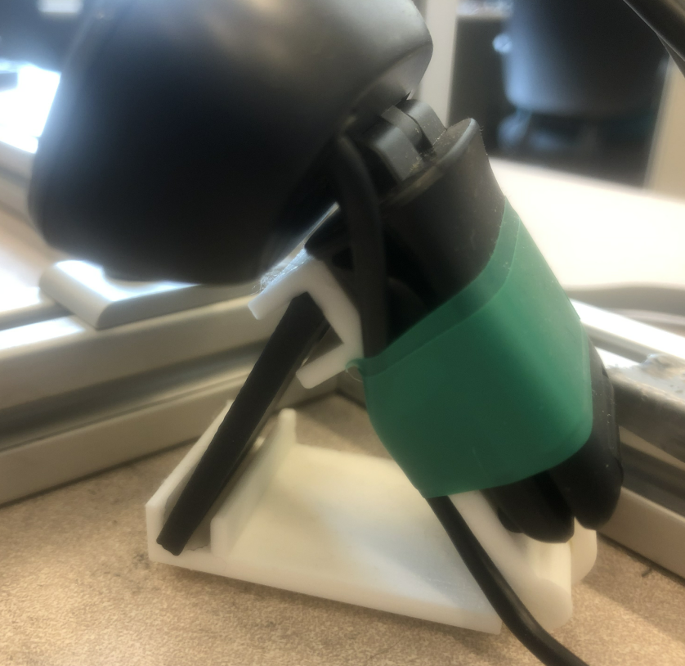

## System Request

**Operation System:** Ubuntu 16.04, Windows 10(for MATLAB)

**Software:** ROS(kinetic), Python 3.6 (We use spyder), MATLAB 2016b

**Python Environment:** <https://anaconda.org/phn1993/with_openCV/files>

**USB ports:** 4 x usb2.0 or 2 x usb3.0 ports. Because each 2.0 port can drive 1 camera and each 3.0 port can drive 2 cameras.

## 4. Software Installation

### 1. Download the programs from github

<https://github.com/HaonanPeng/RAVEN_DNN_CV/>

Download the ‘cv_part’

For now, the repo is private but it will soon be published. Currently the code is provided with this user guide.

The code contains three parts, ‘matlab_part’, ‘cv_part’, and ‘ros_part’, all the three parts are needed later.

### 2. Prepare ROS program

#### 2.1 Install OpenCV on Ubuntu

Following is a tutorial on installing OpenCV on ubuntu, if it is not installed.

<https://www.learnopencv.com/install-opencv3-on-ubuntu/>

#### 2.2 Install ROS OpenNI and OpenKinect (freenect) Drivers

$ sudo apt-get install ros-kinetic-openni-* ros-kinetic-openni2-* \ ros-kinetic-freenect-*

$ rospack profile

#### 2.3 Installing a webcam driver

(Please notice that ‘catkin_ws’ is the workspace of ROS. Change it to suit your workspace)

$ cd ~/catkin_ws/src  
$ git clone https://github.com/bosch-ros-pkg/usb_cam.git  
$ cd ~/catkin_ws  
$ catkin_make  
$ rospack profile

#### 2.4 Test the camera and the driver

$ roslaunch usb_cam usb_cam-test.launch

Or

$ rosrun usb_cam usb_cam_node

$ rosrun image_view image_view image:=/usb_cam/image_raw

#### 2.5 Install raven image recorder

Copy the folder ‘raven_img_recorder’ into the ‘src’ folder of your ROS workspace.

(Please notice that ‘catkin_ws’ is the workspace of ROS. Change it to suit your workspace)

Open a termial run:

$ cd ~/catkin_ws  
$ catkin_make

Then, go to ‘raven_img_recorder/src’, for each .py file, give execute permission by running:

$ chmod +x [raven_img_recorder.py]

where [raven_img_recorder.py] is the name of each file

#### 2.6 Camera calibration

First, install packages

$ sudo apt install ros-kinetic-camera-calibration

$ sudo apt install ros-kinetic-uvc-camera

Next, test the cam and driver

$ rosrun usb_cam usb_cam_node

$ rosrun raven_img_recorder init_cam0_720p.launch

Check if there is proper image, then close

Note that the topic name here may need to be changed

Then, run the calibrator

$ rosrun camera_calibration cameracalibrator.py –size 8×6 –square 0.0255 image:=/usb_cam0/image_raw

Note that the topic name here may need to be changed

A calibration window will appear. If you are not familiar with calibration, please see the following tutorial and follow from part 3 to the end.

<http://wiki.ros.org/camera_calibration/Tutorials/MonocularCalibration>

Find the saved calibration file, it is a .zip file. Open it and you will see a number of pictures and two .ost files. Keep the pictures, we will use them in MATLAB.

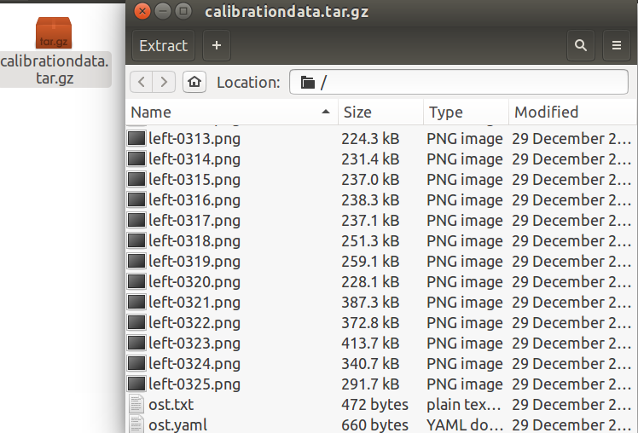

Following is the additional calibration for ROS camera, it will let ROS start every camera with the calibration file you provide. But is it not used in our code. The undistortion is done by MATLAB in our project.

(Find ost.yaml, rename it into ‘head_camera.yaml’. Open it, find ‘camera_name: narrow_stereo’, change the name into ‘camera_name: head_camera’

Move the file to “/home/haonan/.ros/camera_info”, notice that the location may change according to different computer)

#### 2.7 Some potential error for ROS part

Sometimes it shows like :

[rosrun] Couldn't find executable named raven_img_recorder.py below /home/haonan/catkin_ws/src/raven_img_recorder

[rosrun] Found the following, but they're either not files,

[rosrun] or not executable:

[rosrun] /home/haonan/catkin_ws/src/raven_img_recorder/src/raven_img_recorder.py

We need to give execute permission

$ chmod +x raven_img_recorder.py

When using C270 camera, it may shows “outbuf size mismatch.” when using “usb_cam” as the driver. In this situation, go to the source file of the driver: “usb_cam.cpp”, find the line “avframe_camera_size_ = avpicture_get_size(AV_PIX_FMT_YUV422P, image_width, image_height);”, then change “AV_PIX_FMT_YUV422P” into “AV_PIX_FMT_YUV420P”

Some times when recording finished, and ctrl+C was pressed, but the terminal shows escalating to SIGTERM and the bag file have name *.bag.active, this means that it did not shut down cleanly. The bag need to be fixed.

If a bag was not closed cleanly, then the index information may be corrupted. Two steps are needed to repair the bag:

$ rosbag reindex *.bag.active

$ rosbag fix *.bag.active repaired.bag

Or, there it can also be fixed by: In the launch file, change the argument into:

args="--lz4 -b 0 -O camera1_recorder.bag /usb_cam1/image_raw

--lz4 means using a faster but less powerful compressing method, -b 0 means infinite buffer size.

Sometimes the img_extractor is running correctly, but cannot saving files, this may be because the folder is not created. The cv2.write sometimes cannot create folders if the folders are not manually created.

Sometimes the webcam driver works well, which means that the video looks smooth, but the recorded bag files are small and many frames are missing. This can be caused by the buffer size and the compress method. In the launch file, change the argument into:

args="--lz4 -b 0 -O camera1_recorder.bag /usb_cam1/image_raw

--lz4 means using a faster but less powerful compressing method, -b 0 means infinite buffer size.

### 3. Prepare python programs

The core program need to be run in python environment. If you are not familiar about what is going on, we recommend using Anaconda and Spyder.

Install environment on your PC, the yaml file can be found at: <https://anaconda.org/phn1993/with_openCV/files>

Currently, the prepare is done as long as you have correct python environment and the downloaded ‘cv_part’ programs.

### 4. Prepare MATLAB programs

No preparation is needed as long as you have MATLAB 2016b (or compatible version) and the downloaded ‘matlab_part’ programs.

## 5. Setting Recording Environment

### 1. Placing and fixing cameras around the workspace

Place 4 cameras around the workspace. They should be separated to avoid the blocking of the balls, because the CV program will always need at least two cameras’ successful detection for each ball.

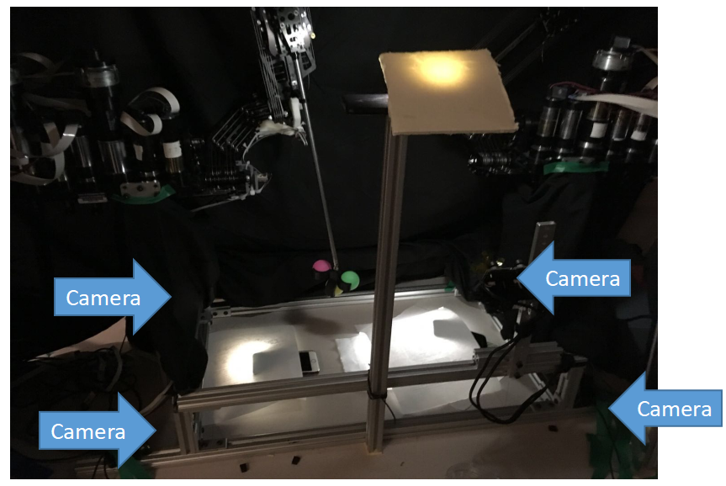 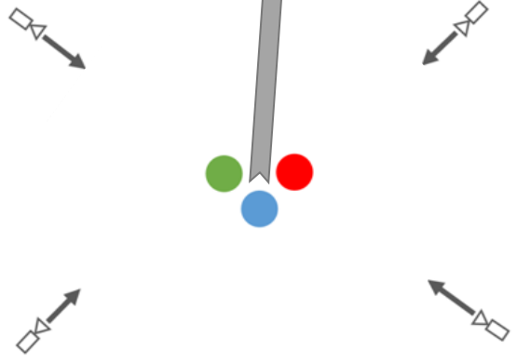

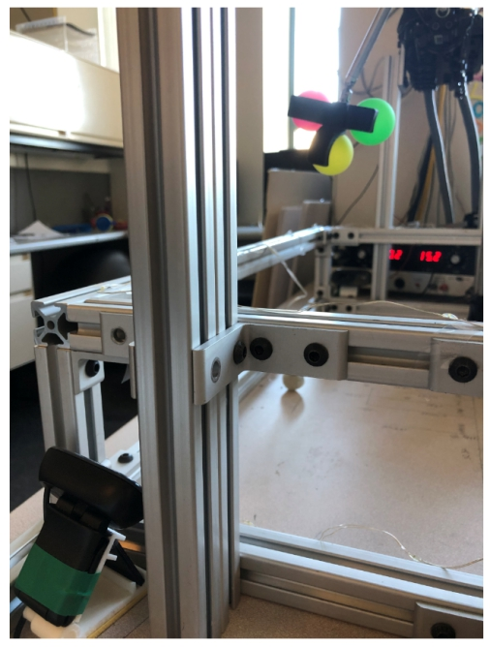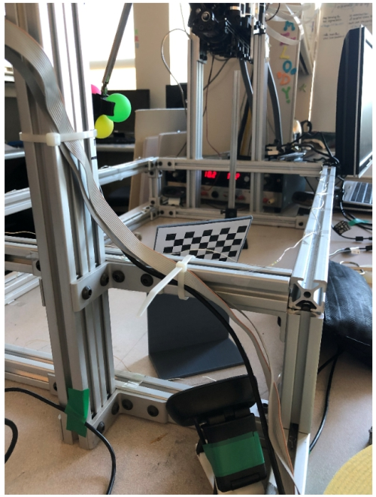

You are free to choose any fixing method. For us, we are using a very simple 3-D printed camera holder to do so. The model can be found in the ‘Solidworks Model/camera’ folder. You can print different size of the slice(the black part) to adjust the pitch of the camera. (For the C270 camera, it has a hinge to adjust pitch. However, it is not recommended because if you use that, a single touch during recording may change the pitch, which is catastrophic because the program requires the cameras to be strictly fixed. Thus, always keep that hinge to lower limit is recommended, just as the following picture shows)



Connect the cameras to the usb ports.

Open a terminal, run:

$ roslaunch raven_img_recorder init_cam0123_720p.launch

You could see 4 image windows (following picture only shows two, and if you are connecting the cameras to 2 computers, please see later instruction). Adjust the cameras to ensure they have clear sight of the workspace. Then fix them on the table.

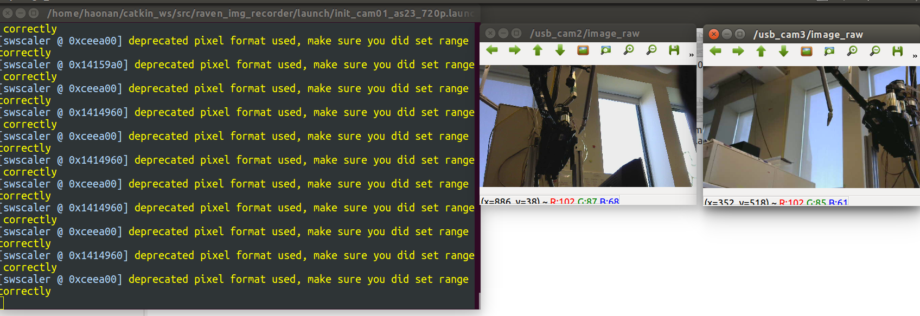

### 2. Cover the environment background with thick black cloth

It is highly recommended to cover the environment with black cloth, if the background is complex because the circle detection is sensitive to environmental noise. Thus blocking background and natural light can improve the performance of the system.

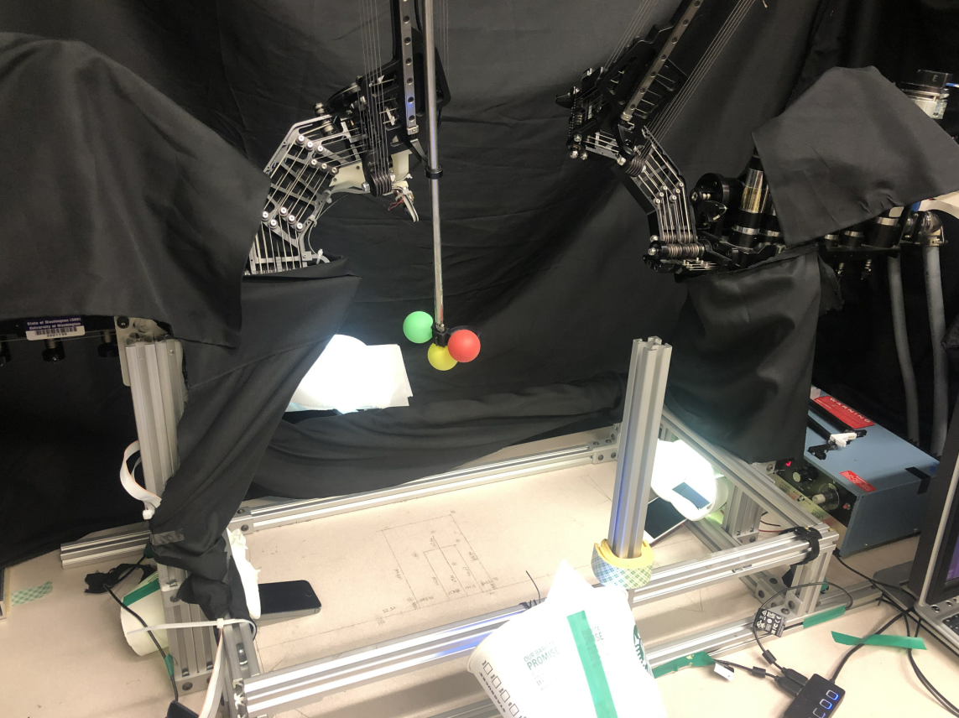 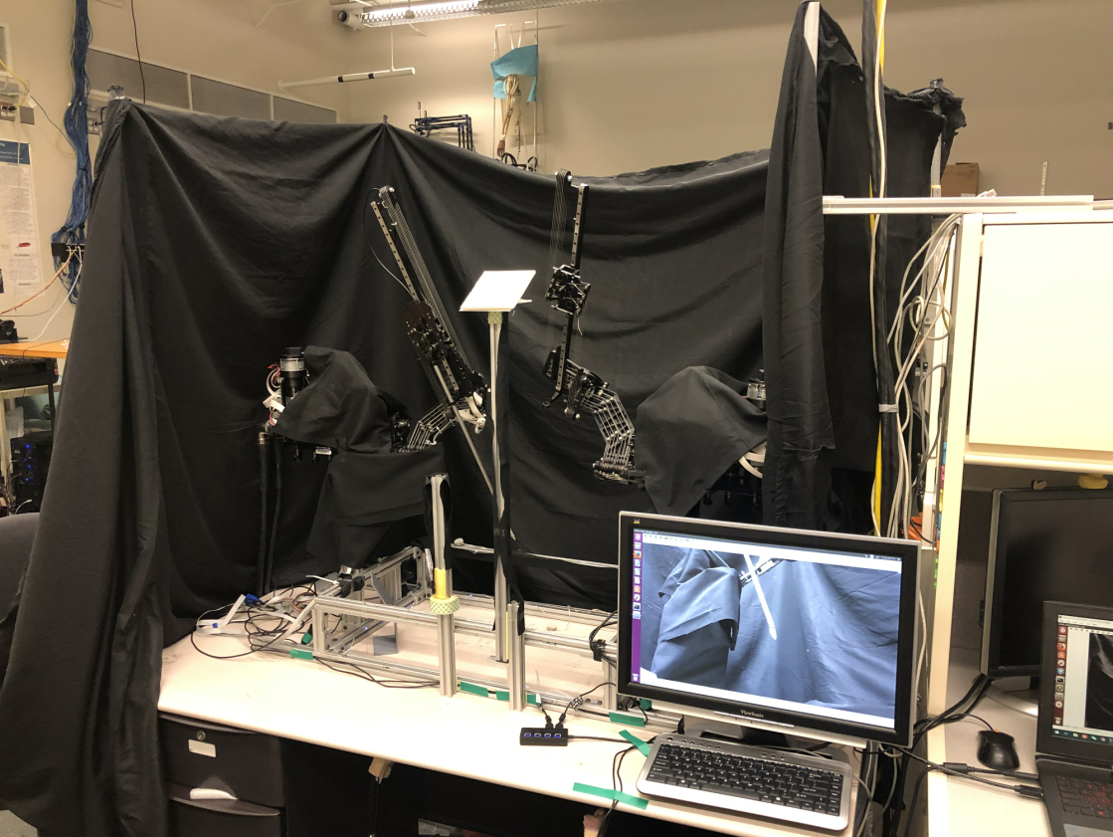

### 3. Set up proper lighting

Because the environment is surrounded by black cloth, we should provide proper lighting. Just as the previous picture shows, it is not hard to light the work space, by using cellphone’s lights and paper cups. If you are using the method, sometimes you need to place some paper in front of the lights to weaken it to prevent overexposure.

A good image from the cameras should have proper lightness and distinct colors for different balls, as the following pictures show (usually the red ball is a bit darker. This is usually acceptable since the color detection is using sample points, which will be introduced later).

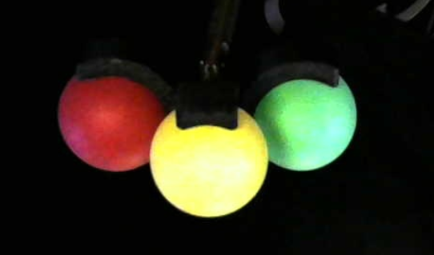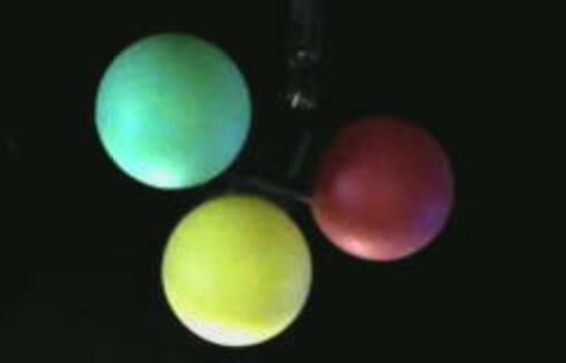

### 4. Set up markers

On the table, choose an origin point and cordinnate (all the measurement provided will be related to this origin point and coordinate).

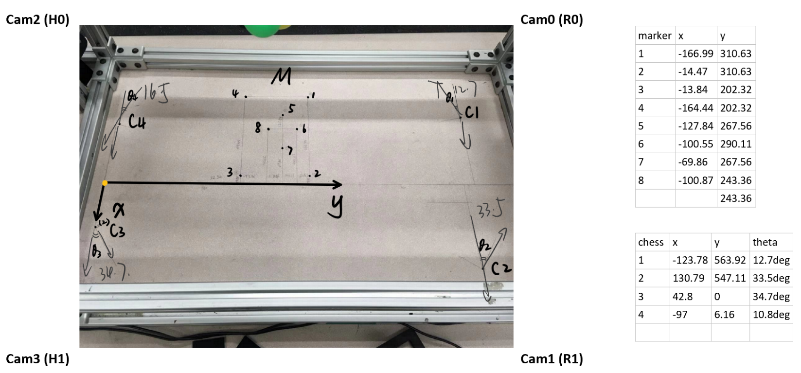

Choose chessboard place, which is c1 – c4 in the picture (a point for position and a line for orientation). The position and orientation of the chessboard should be known. Please notice that for the program, instead of the point and the line on the table, the origin frame of the chessboard(usually the left top corner) is needed. So the holder of the chess board should have known size.

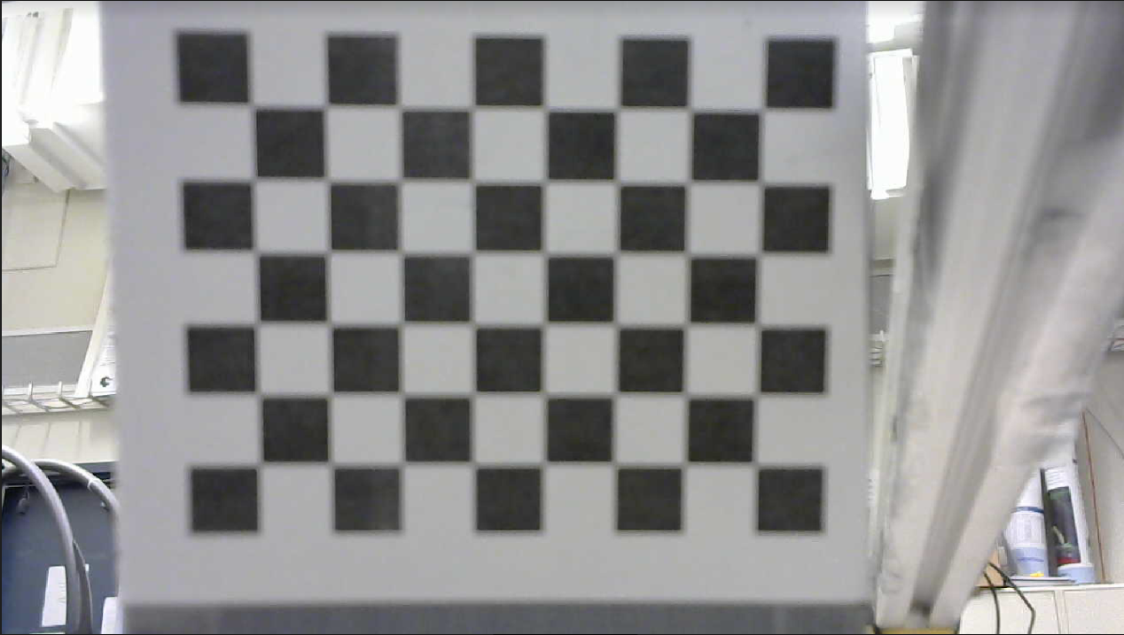

Choose marker points place, which is 1-8 in the picture, please make sure that the marker points can surround the workspace and some are inside the workspace. Also, it is important to make sure that for each marker place, the marker points can be seen by all the cameras.

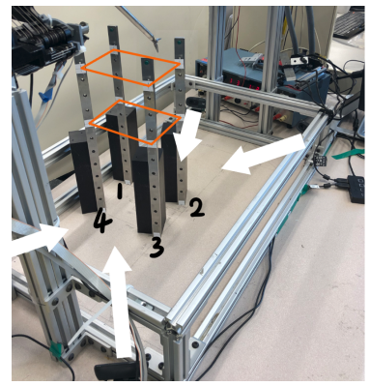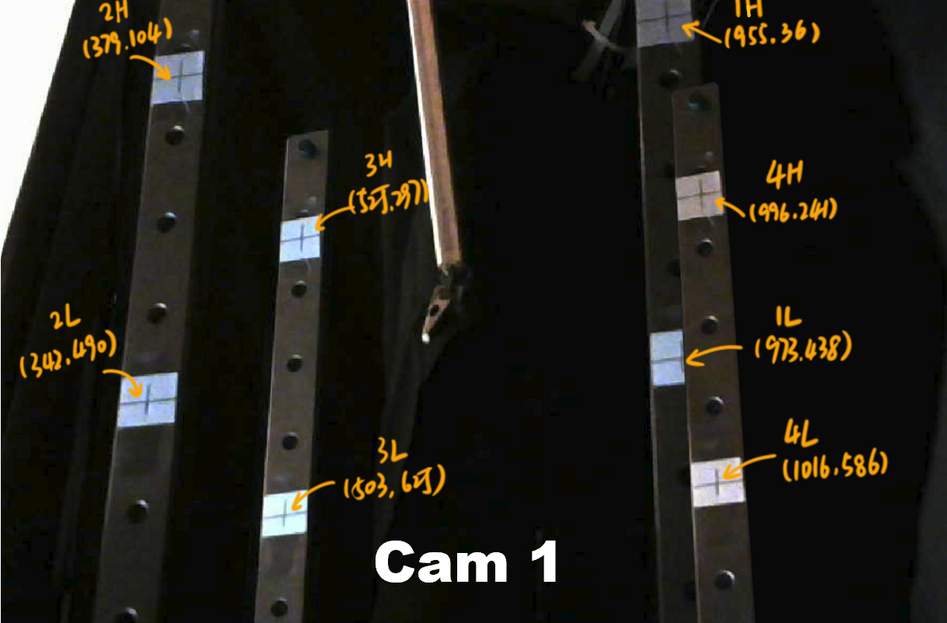

## 6. Data Recording

### 1. Set up environment

Set up the recording environment according to the previous section and have the ROS part program done.

Connect the cameras.

### 2. Start the cameras

It is recommended to connect all the 4 cameras to 1 PC. But sometimes a 2-2 separation is needed. For example, the RAVEN II at BRL UW already takes two 3.0 usb ports so that there are not enough ports for the cameras. Thus for our group, we connect 2 cameras to the RAVEN computer and the other 2 cameras to another PC. When doing this 2-2 separation, some changes are needed, which will be specified later.

Please notice that for some laptops, because there may be a built-in headcam, the device number may be changed. Usually, for a laptop with headcam, open the launch file used later, find the two lines:

<param name="video_device" value="/dev/video0" />

<param name="video_device" value="/dev/video1" />

change them into:

<param name="video_device" value="/dev/video1" />

<param name="video_device" value="/dev/video2" />

**For 4 cameras – 1 PC:**

Open a terminal and run

$ roslaunch raven_img_recorder init_cam0123_720p.launch

You should see 4 windows showing the 4 cameras image flow.

**For 2-2 separation:**

On one PC (for us, the RAVEN PC), run:

$ roslaunch raven_img_recorder init_cam01_720p.launch

You should see 2 windows showing camera No.0 and No.1

On another PC, run:

$ roslaunch raven_img_recorder init_cam01_as23_720p.launch

You should see 2 windows showing camera No.2 and No.3

### 3. Record chessboard and markers

For each camera, save the images of the chessboard(1 for each camera) and markers(multiple positions, recommended 8 at a minimum), by clicking on the save button of the camera window (before saving, it is usually a good choice to maximum the windows to increase the resolution of the saved image. And also please note that the resolution may not be 1280 x 720p(the working resolution), and it will need to be adjusted to working resolution 720p.).

For us, we are using 8 markers so there will be 9 images for each camera. Please notice that for the chessboard and markers, their physical location is needed later to localize the cameras.

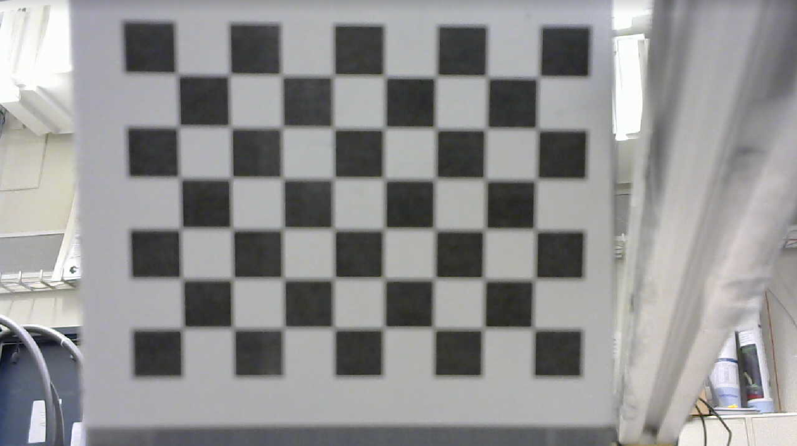 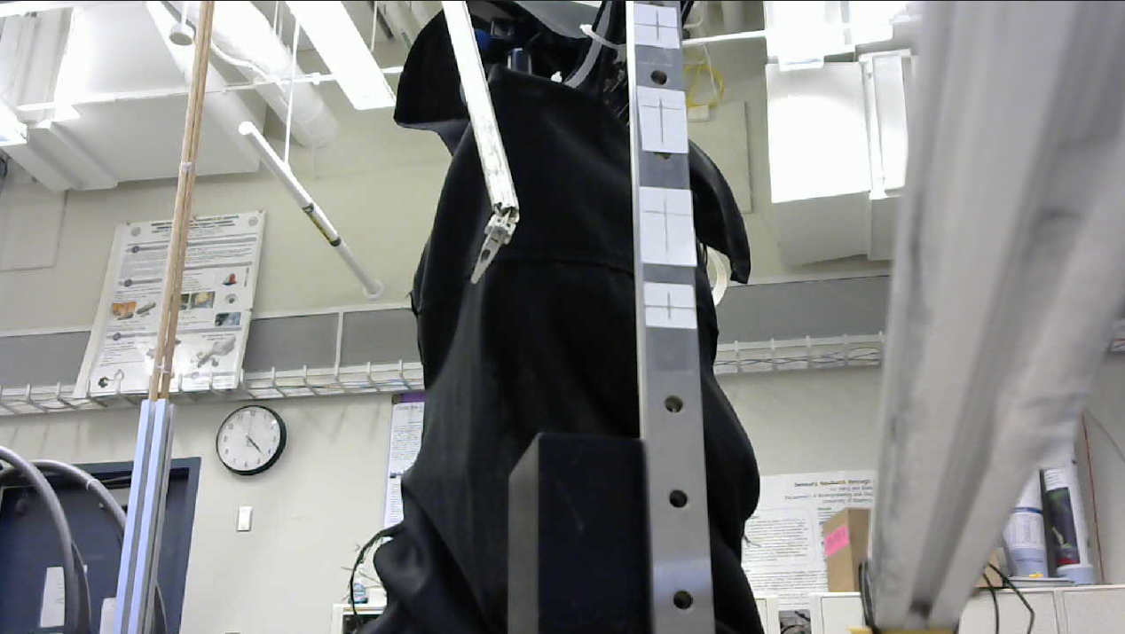

### 4. Prepare for recording

Set the environment for recording, including covering the background and provide light so that the cameras can have proper sight.

If you work with RAVEN, start RAVEN. There are multiple tutorials on operating RAVEN which could be found online.

 

### 5. Recording

Open a new terminal, run:

$ roslaunch raven_img_recorder recorder_cam0123_uncompress.launch

when done recording, use ctrl+c to stop. For each camera, a rosbag file will be saved. Usually they can be found at home/.ros with name of cameraX_recorder.bag. And if you are working with RAVEN, a file named raven_state_recorder will also be saved.

For 2-2 separation. There will be bag files for all the cameras on both computer. However, only the bag files with cameras have data in it. The other bag files will be empty (with size of only 1-10 kB).

Keep the bag files, the images will be extracted later. Make sure that before you start a new recording, save the bag files to another place. The bag files will be overlapped in the folder ‘.ros’

### 6. Time difference test (for 2-2 separation only):

The system uses ROS time as the timeline. So if you do 2-2 separation, a calibration of ROS time between the two computers is needed. There are multiple ways. We are using a simple method, by having 2 cameras from 2 computers to record the same timer (the same as you record data). After recording, open a terminal and run

$ rqt bag

Then, open the recorded bagfiles on both computer. Right click on the time line and open ‘raw’ and ‘img’. From the header – stamp, you can see the ROS time. Make sure the image shows the same time and compare the ROS time difference. Repeat for multiple times and take an average. Keep this time difference constant, which will be used later.

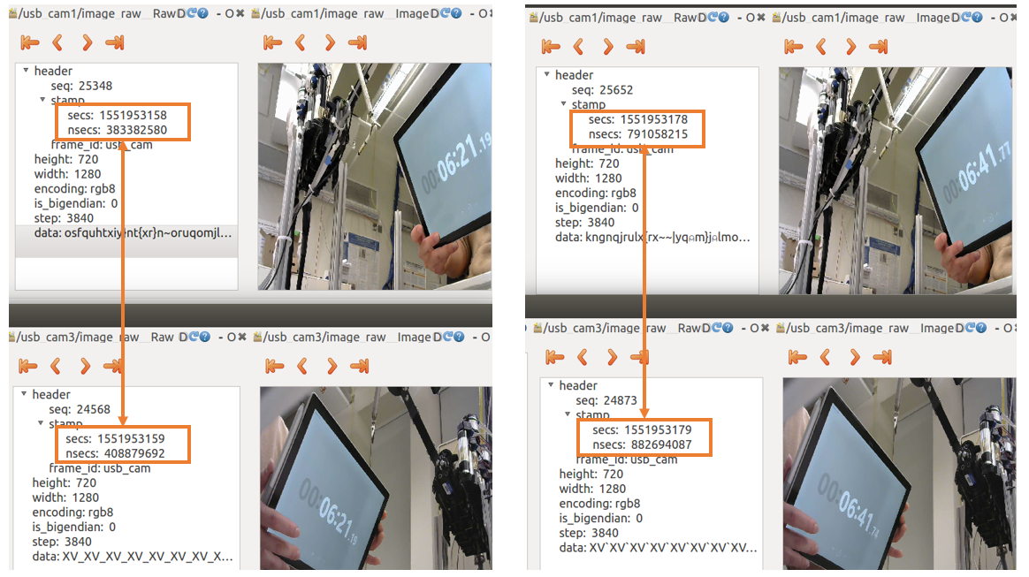

## 7. Processing rosbag files

### 1. Prepare to extract images

After data recording, we now have 5 bag files for a single recording(4 camera files and 1 raven file, even you are not working with RAVEN(an empty file)).

Go to the ‘src’ folder of raven_img_recorder, open the file ‘img_bag_reader.py’. Find the line 25 and change the working folder to fit you.

Then copy all the 5 bag files to that folder and create 4 empty folders named ‘img_camera0’, ‘img_camera1’, ‘img_camera2’, ‘img_camera3’. A ready-to-go workspace should looks like following:

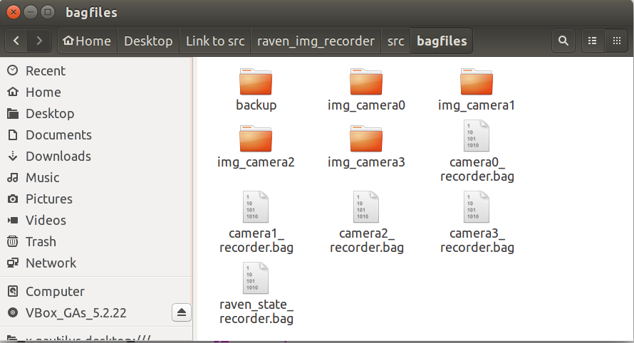

### 2. Extracting images

Then, open a terminal and run:

$ roslaunch raven_img_recorder img_extractor0123.launch

You can see the following massages, which means that the program is extracting images from ROS bag files

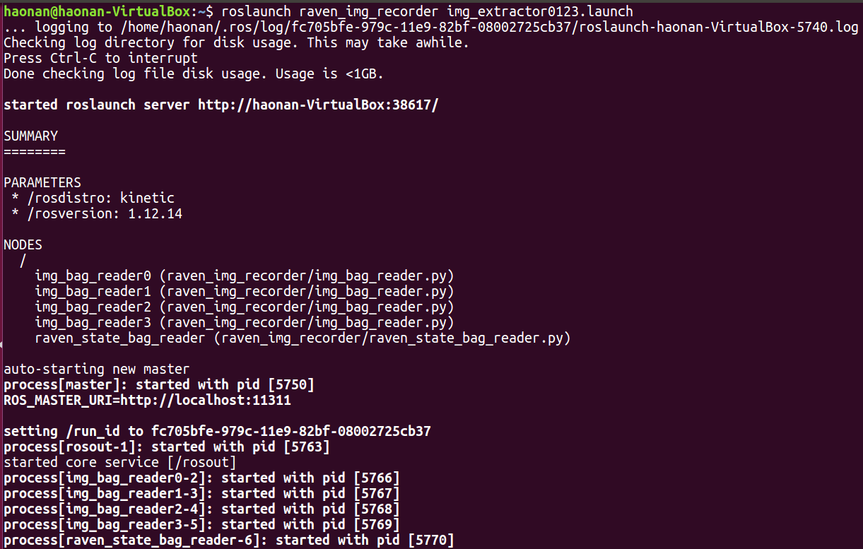

The procedure is finished when you see the following messages.

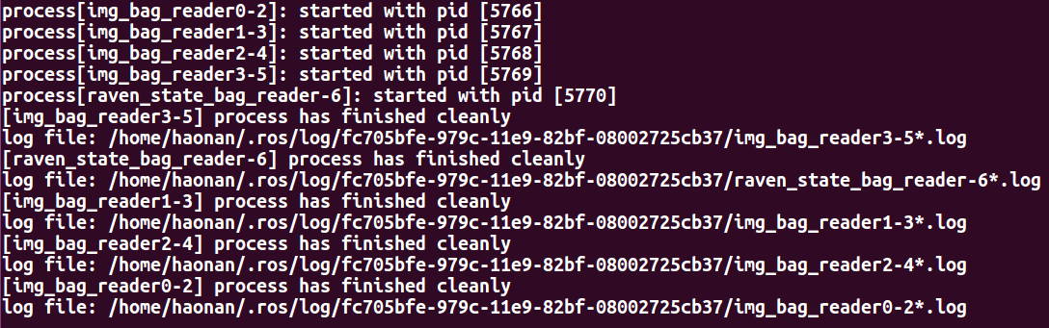

After this, when you open a camera folder, you can see images are extracted and named after the ROS time. And there is also a .txt file that stores the time stamps and can be imported as a numpy array.

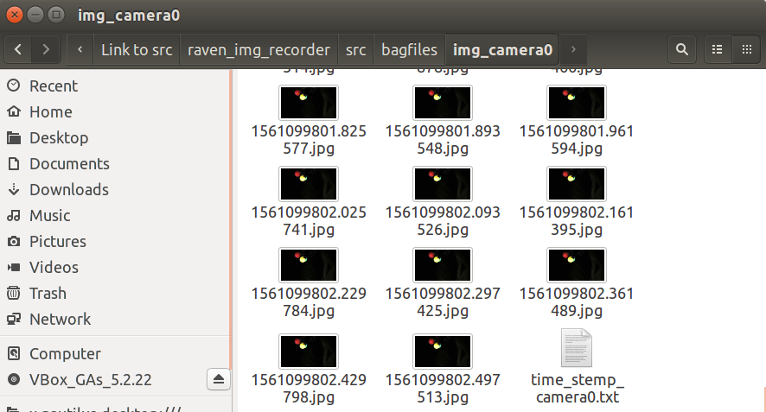

## 8. Camera Localization

From this part, we will begin to use MATLAB and windows.

1. Import the valid set of chessboard calibration sample frames into MATLAB camera calibration toolbox, run the calibration and save the camera extrinsic parameters as “cameraParams.dat” under “Camera Calibration” folder.
2. Adjust the resolution of the chessboard and marker images to the same as video if they are not.
3. Run the “undistortion_rename.m” file in MATLAB to undistort the marker images with the “cameraParams.dat” previously created - the “image_folder_open” and “image_folder_open” should be changed to the current local path.
4. Use the image processing software such as Photoshop to pin and record the image coordinate (X, Y) of each marker in marker images.
5. (Optional) Briefly process the chessboard images to make the chessboard area clearer by blocking the background, enhance contrast, denoise, etc. This would help make MATLAB’s chessboard detection more robust.
6. Run MATLAB function “detectCheckerboardPoints” on the chessboard images, and record the origin and XY axis of the chessboard detection result (Y axis is 90° clockwise rotation of X axis), refer the images back to the pose in world, and record the detected chessboard position(origin) and orientation in world coordinate.
7. Make sure “Camera_Info_txt” folder is empty, and then run “camera_info_definition.m” file in MATLAB after:
8. Change “working_path” to the current path of root folder which contains “bagfiles”, “Camera Calibratioin” and “Camera_Info_txt” folders
9. Change focal length of the webcam – parameter “f”
10. Change pixel size in real world (millimeter as the unit) – parameter “ps”
11. Change video resolution – parameter “resolution”
12. Change the size of single square on chessboard – parameter “squareSize”
13. Change the chessboard position(vector) and orientation(matrix) in world coordinate – parameter “P_chess” and “R_chess”
14. Change the list of marker number and the corresponding markers’ position in world coordinate – parameter “num_ref” and “P_obj”
15. Change the image coordinate of the markers for each camera – parameter “Image_object_center”
16. Check the output in MATLAB’s command window:
17. “position_difference” refers to the camera position difference between the result from chessboard detection and the result after marker-correction.
18. “ERROR_now” refers to the difference between marker’s true position and ones inversely calculated by the new camera position with image coordinate (in the order of previous parameter “num_ref”). If a few values are obviously larger than others, then it might be the incorrect input of the marker’s image coordinate. If the average error of one camera are obviously larger than others, then it might be the incorrect input of chessboard position and orientation.
19. If incorrect input is found in previous check, then repeat step **6 to 7**, after these there should be 10 txt files created under “Camera_Info_txt” folder

## 9. Undistort images

### 1. Set up workspace

Set up workspace like the following left (I have multiple trajectories, each one will be a folder).

From the MATLAB code part, copy undistortion_cam.m to this folder.

From Step 8, copy the result ‘cameraParams.dat’ to this folder.

In each trajectory folder, create a folder named ‘bagfiles’, and then copy the result files from Step 7 (4 image folders and 1 ravenstate.txt). If you are not working with RAVEN, just open a camera’s folder and copy the time stamp file and name it as ‘ravenstate.txt’

Rename the image folders, add ‘_distort’ to each original image folders, such as ‘img_camera0’ to ‘image_camera0_distort’

Create empty folders named : ‘img_camera0’ ‘img_camera1’ ‘img_camera2’ ‘img_camera3’ and ‘selected_frames_cam0’ ‘selected_frames_cam1’ ‘selected_frames_cam2’ ‘selected_frames_cam3’

From folder ‘img_camera0_distort’, copy ‘time_stemp_camera0.txt’ to folder ‘img_camera0’, repeat this for other cameras.

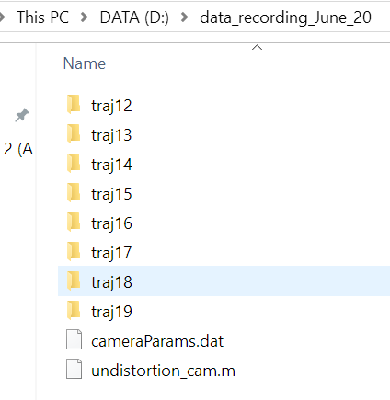 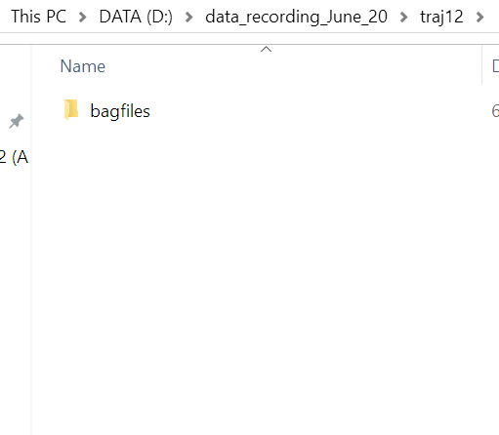

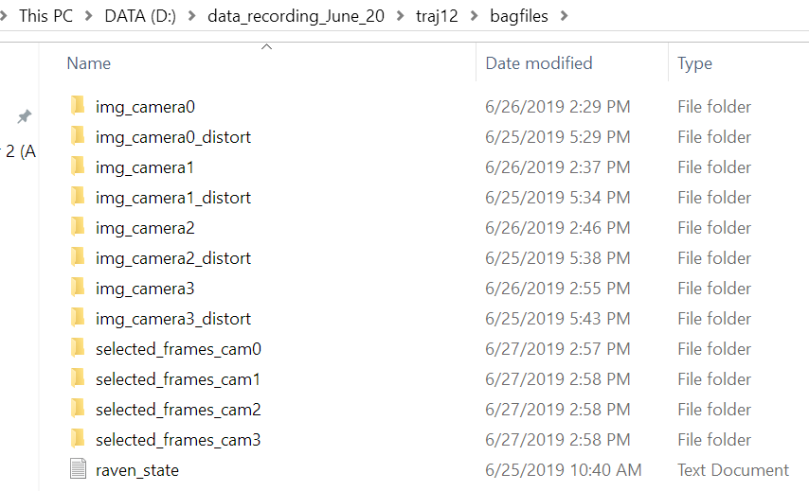

### 2. Undistort images

Now you should have the workspace set. Use MATLAB to open the udistortion.m, change the folder path to fit your PC. Please notice that there are 4 sections and each one contains the path.

Now run the program. This may take a while and when it is done, in the folders ‘img_camera0’( also for camera 123), you could find undistorted images with same name as their original images.

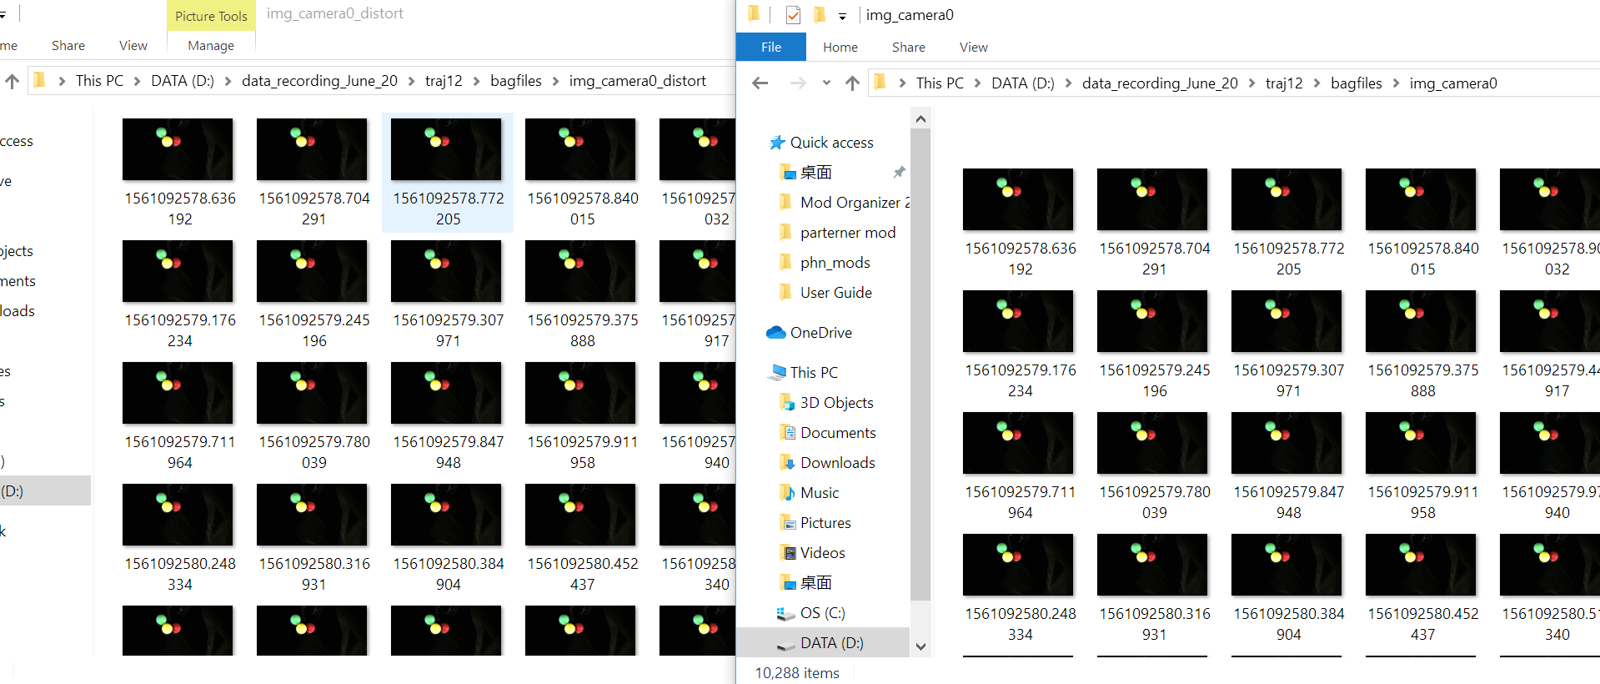

## 10. Image Processing

Now we are ready to processing the images. Copy all the ‘cv_part’ code to the ‘traj’ folder. A ready-to-go workspace should looks like the following, and notice that the folder ‘Camera_Info_txt’ comes from Step 8 camera localization.

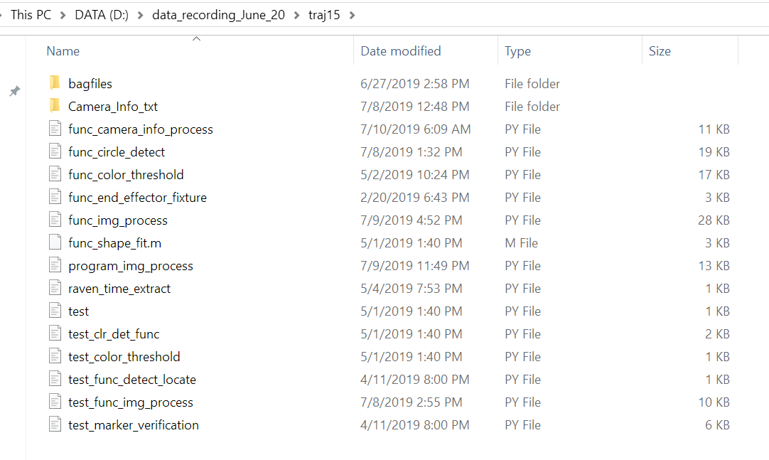

### 1. Extract ravenstate time

Run ‘raven_time_extract’, it will generate a new .txt file named ‘raven_state_time.txt’

If you are not working with RAVEN, just copy a one camera’s time file such as ‘time_stemp_camera0.txt’ and rename it into ‘raven_state_time.txt’ and place it at the folder ‘bagfiles/’

### 2. Setup color reference

Open file ‘func_color_threshold.py’, you could see the first part contains many sample points of the three balls color (currently we are using green, yellow and red). Each sample point contains three number, which is the blue, green and red color channel of the point (please notice the sequence is BGR not RGB, because BGR is used in openCV).

If you are using the same colors and have similar lightness, these sample point should be usable. However, if you are using different colors, the sample points should be replaced by your situation. Notice that when you replace the colors, the place of the yellow one should always be the ball that is in the center. Also, the sample points should contain different lightness of a single color from dark to light.

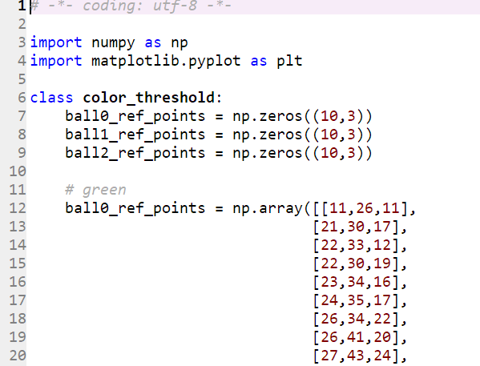

You can run ‘test_color_threshold.py’ to see if the result is satisfying.

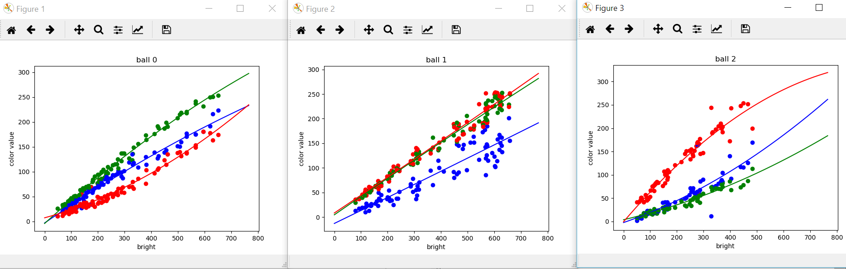

### 3. Setup the time difference (for 2-2 separation)

If you are separating cameras on 2 computers, go to ‘func_img_process.py’ and find the line

‘time_difference = -1.5’ and change it into your measurement (second), which is mentioned before. If the camera 2&3 is ahead of camera 0&1, this value should be negative.

### 4. Setup initial radius

Open ‘program_img_process.py’, this is the main program of the image process. There are two lines ‘set_write_log’ and ‘set_show_plot.’

If ‘set_write_log(1)’, the output message will be written into a log file instead of shown in the console. This is because when processing thousands of frames, the previous messages can be lost when shown in console.

If ‘set_show_plot(1)’, the program will output result image, this is mainly for debugging and adjust parameters. When processing many frames, set this to 0.

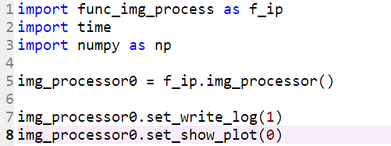

You can also find the initial values of the radius of each ball in each camera as the following picture shows. The sequence of the balls are green, yellow, red (1st, 2nd, 3rd column). You need to setup an initial value of the max and min radius of the balls in each cameras image. The value mean the radius in pixel (set it in float numbers). This range must include the true radius and can be relatively large. You can set these values manually of just give it a wide range. The system will soon converge the range when processing images.

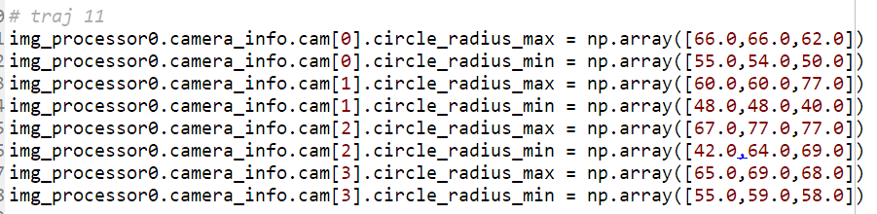

However, if you face some problem when doing so. You can first set the max_frames to a small value such as 10 or 20 and run the program with a very wide range such as 20 to 150 for our case. Then you can observe the output result and the result images can be find in ‘selected_frames’ folders. If the result is satisfying you can use the output radius in the console as the initial radius. If not, adjust the range and repeat.

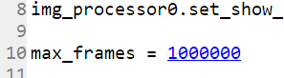

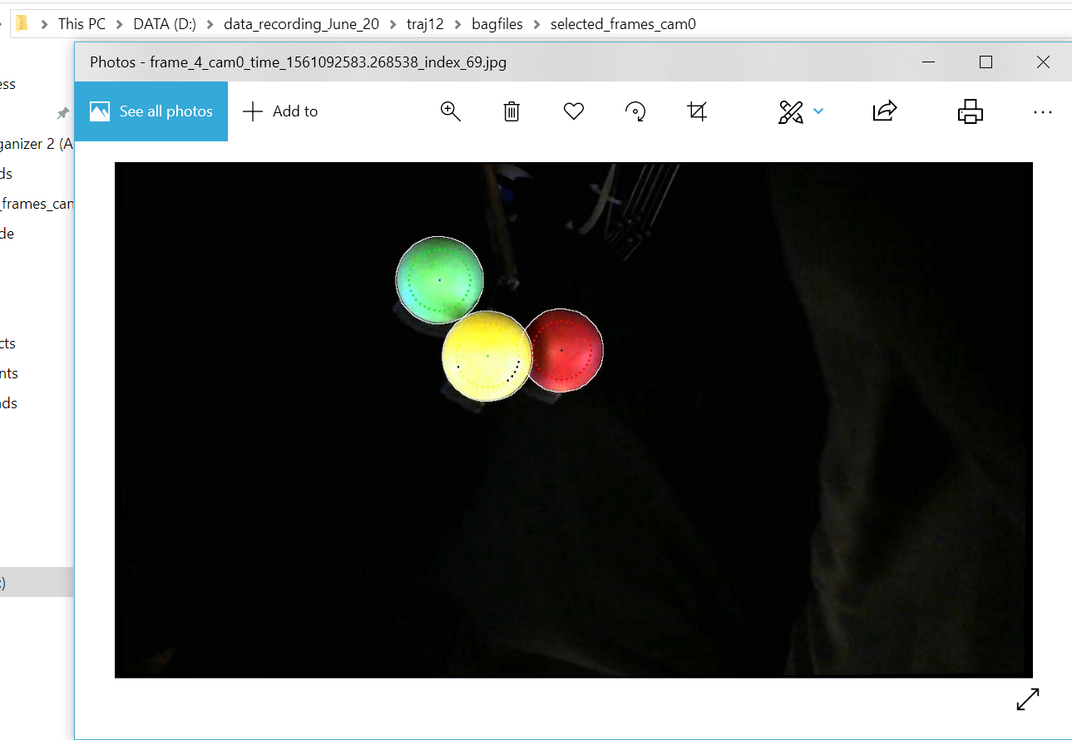

### 5. Process images

Open ‘program_img_process.py’

Now you are ready to process the images, it is recommended to set write log to 1 and show plot to 0. Set the max frame to fit you. The max frame can be larger than the actual frames you have and in that case the program will finally end with a ‘out of bounds’ error. But every thing will be good.

The processing can take a relatively long time. Because the Hough circle detection is multi-threaded, the CPU load may raise to 100%. If you are advanced user, changing Hough circle detection to a more efficient algorithm can significantly increase the speed.

When the procedure is done, the location of the balls will be stored in a .txt file named ‘img_process_result.txt’ at the root folder. Each line of the file indicate for 1 selected frame. The first column is the frame counter and the second column is the ROS time (average of the cameras and RAVEN). And the next 9 columns are the x, y, z, position of the green ball, of the yellow ball and of the red ball, in the world coordinate frame you choose.

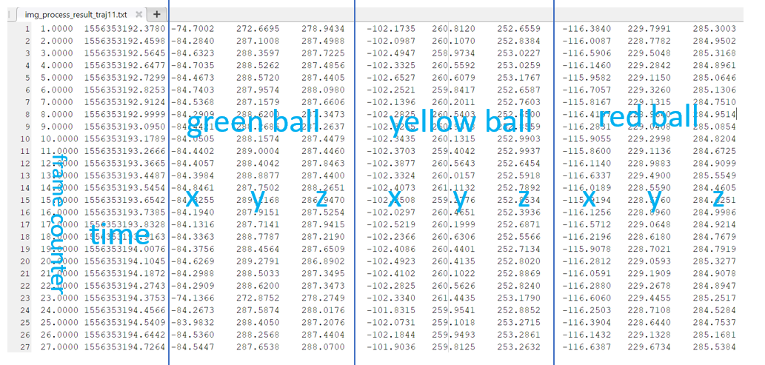

The result images can be found in the ‘selected_frames’ folders, a result image may looks like following. The write circle is the detected balls’ edge. The center of the circle is also pointed out. And the points around the circles are the color sample points, these points will be black if it can not be recognize as either of the three colors of the balls.

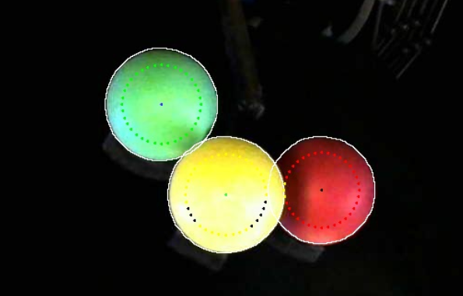

The images will be named after ‘frame’, which is the system’s frame, and then ‘time’, which is the ROS time, then ‘index’, which is the index of the belonged camera.



The following is the log of a single frame,

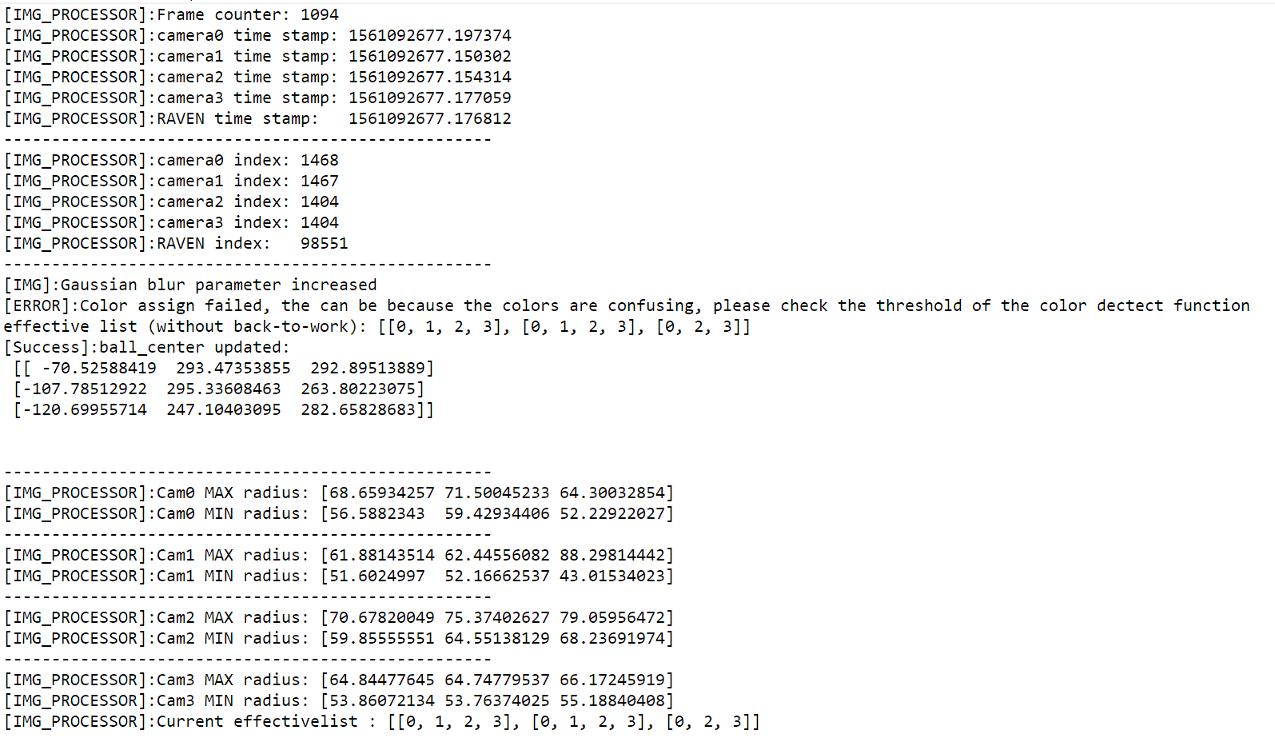

The first line is the frame counter. If you are using the same cameras, the frame should roughly be 10hz.

Next part is the time and index of the cameras.

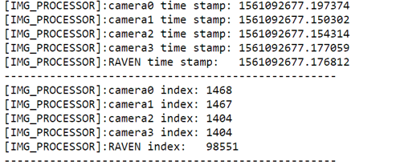

You can see there may be some error indicating that some ball can not be successfully detected.



Effective list is very important. Each array is one ball and the number means the cameras that successfully detected the ball. In the following picture, you can see that for the third ball (red ball), camera 1 can not detect it.



Finally is the detection result and the current range of the circles’ radius, which will be used in the next frame.

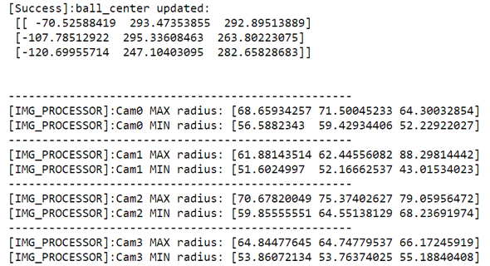

### 7. Frame jump

Sometimes because the recording procedure has some problem which may cause the image to be undetectable such as the following picture. In this situation, the system will return error at this frame and stop processing the rest frames.

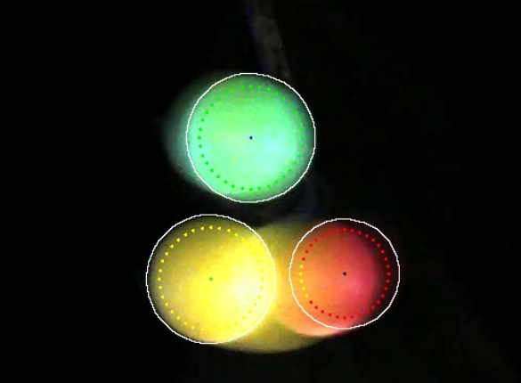

So it is recommend to skip the frames that have problems. Using frame jump function, which is located in the main program ‘program_img_process.py’, find the function ‘frame_jump’:

The arguments of the function:

**jump_type:** It should be ‘auto’, ‘manual’, or None. The ‘auto’ mode will skip the next several frames when a frame is not detectable. The ‘manual’ mode will skip the frames specified by users. And the None mode will turn off frame jump, which means that when a frame is not detectable, the system will exit.

**move_range:** This is a parameter that increase the allowed movement between the two frames before and after frame jump. Normally 20 is good for a slow system to jump 0 – 20 frames. However, if you want to jump more than this, you may need to increase this range.

**auto_jump_frames**: this is only available when choosing auto mode. For example, if = 5, the system will skip the next 5 frames when facing undetectable frame. The following picture shows an example of auto mode.

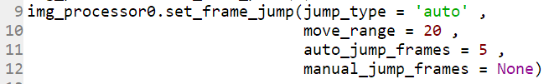

**manual_jump_frames**: this is only available when choosing manual mode. The system will skip the given range of frames. For example, as the following picture shows, the frames 20 – 30 and 60 – 75 will be skipped. (Please notice that even you only want one range, it should also look like [[20 , 30]])

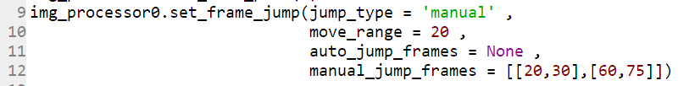

## 11. Trajectory Solving

Normally, if you finished all the work before. Your already have the trajectory of the three balls. Thus you could solve the trajectory using your own method. The following part mainly focus on solve trajectory and do some basic visualization on RAVEN’s trajectories. However, even you are not working with RAVEN, you can also modify our code to get your version.

This part is done in MATLAB because it provide better plots.

### 1. Prepare workspace

First, copy the MATLAB code to the workspace.

Then, create a new folder named ‘data_files’, copy the result file from last part and name it after trajectories number such as ‘img_process_result_traj3.txt’, also copy ‘raven_state.txt’ and name it after trajectories such as ‘raven_state_traj3.txt’

### 2. Filtering data

Because the detected centers of the balls can be noisy, thus the first step is to filter the balls’s centers.

Open ‘raven_CV_data_prefilter.m’ and change the file path of your ‘img_process_result’ file and change the window size of the filter, and then run the code. This will take an average filter on the balls center and generate a new file with a surfix ‘_filtered’ such as ‘img_process_result_traj3_filtered.txt’.

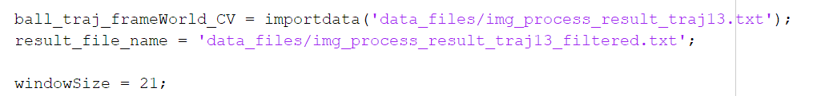

### 3. Solve the center’s position

Open ‘raven_CV_solve_endeffector_PR.m’ and change the file path of your ‘img_process_result’. Notice there are totally 4 lines of file path, 2 lines for filtered and 2 lines of unfiltered.



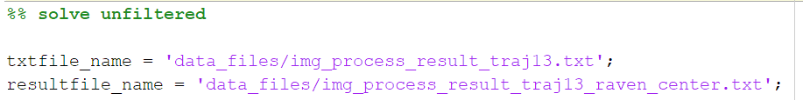

Run the code and it will solve the center of the RAVEN’s end effector’s center in the world frame. The result will be stored in a .txt file named ‘img_process_result_traj13_raven_center_filtered.txt’ and ‘img_process_result_traj13_raven_center.txt’. The txt file can be import as a matrix. A frame is a single line, the first column is the ROS time, and columns 2-4 is the center position x, y ,z. The rest 16 columns are flattened transform matrix. However, currently the solve can not solve the rotation accurately, thus the transform matrix may not be accurate. But the centers’ positions can reach 1-2mm accuracy.

### 4. Toggle raven_state

Before using ‘ravenstate’, because RAVEN’s high refreshing rate, for 10 minutes recording, the ravenstate file can be more than 1 GB, which make it very slow to operating ravenstate. And for our 10hz recording system, have 1000hz ravenstate is not helpful. Thus, toggle raven_state can speed up the following procedure. Also change the ‘toggle_rate’, if toggle_rate = 10, it will decrease ravenstate from 1000hz to 100hz

Open ‘raven_CV_toggle_ravenstate_traj.m’, then change the file path:



Then run the code, it will generate a new .txt file named ‘raven_state_traj14_toggled.txt’ and store the toggled result

### 5. Visualization

Open ‘raven_CV_draw_3D_traj_filtered_with_raven_state.m’ and change the file path, all the required file are generated from previous steps:

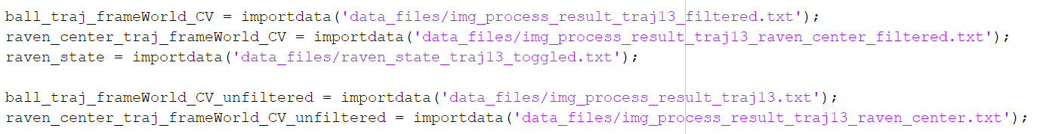

Run the code and it will provide some basic visualization of the trajectory.

